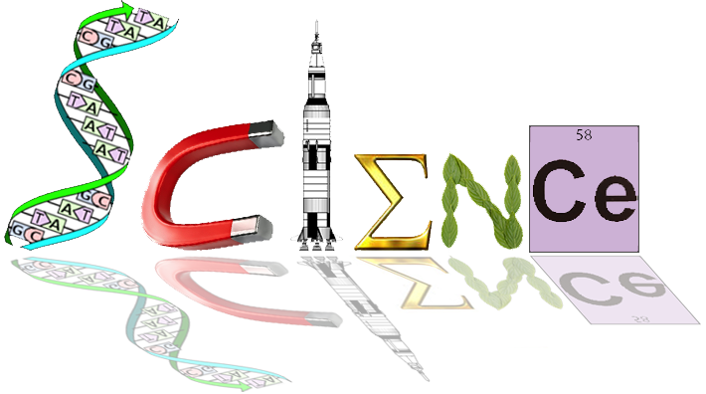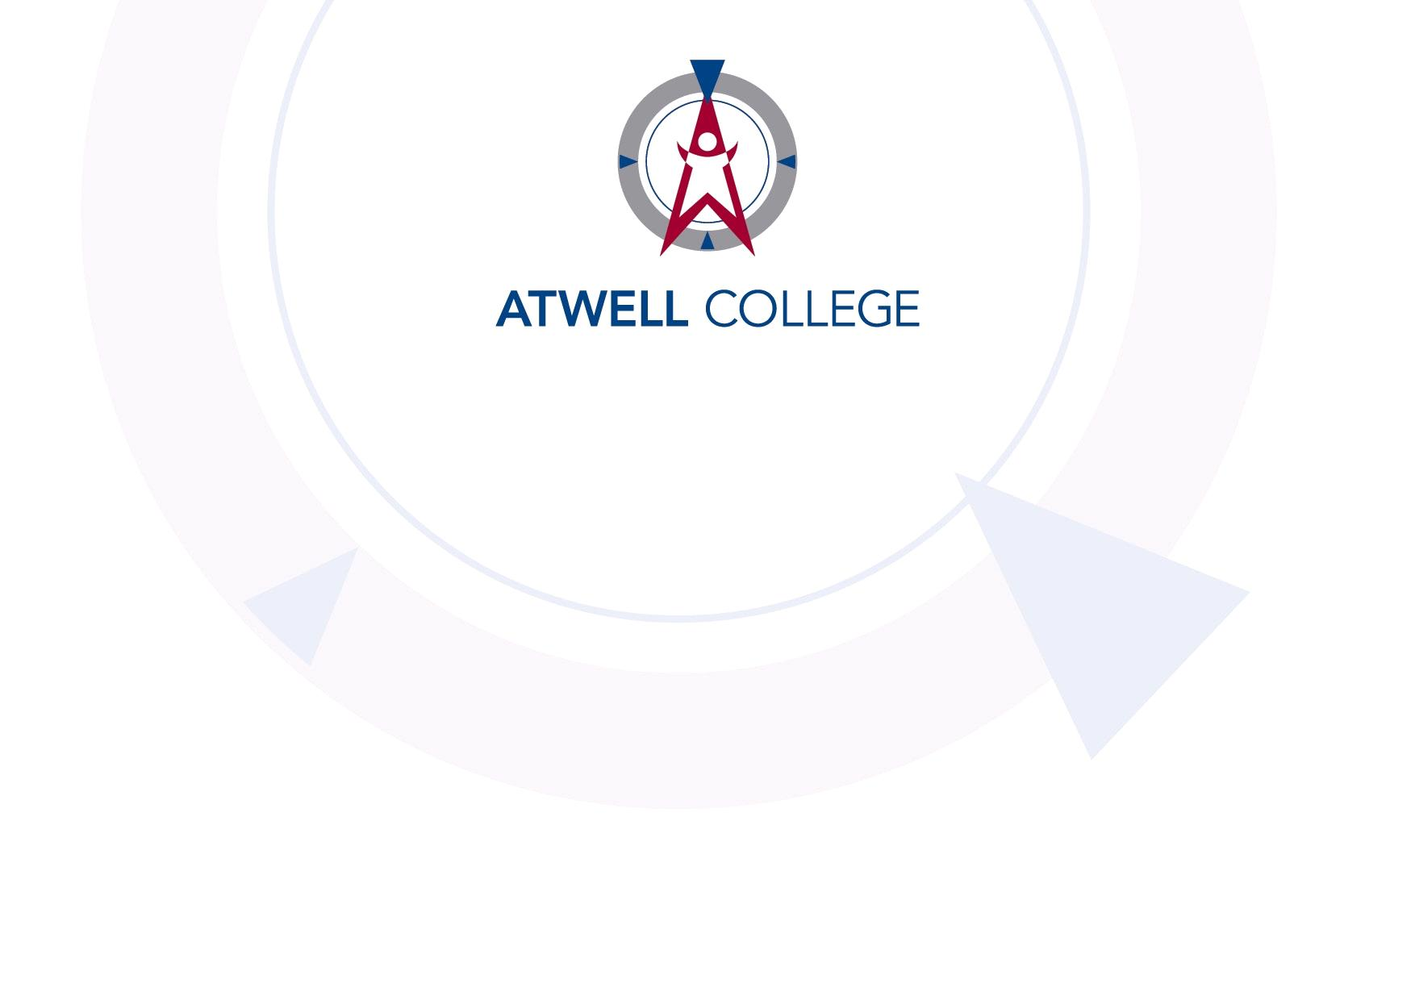

**Year 12 Human Biology**

**Task 10 - Primate Evolution**

**Extended Response**

___/24

Permitted materials – Perth Zoo work booklet

Answer ALL QUESTIONS on the lined paper provided.

DO NOT WRITE IN PENCIL.

Your answer may take the form of:

• Appropriate graphic organisers e.g. a **table**

• Clearly labelled and annotated diagrams

• A list of points, with sentences which link them

Up to two marks may be deducted for poorly constructed answers.

1. Dan, a member of the Atwell College Archaeology Club (ACAC) discovered a fossil of an extinct primate specimen. He concluded that it was one of the most primitive members of the primate order, displaying characteristics much like Lemurs or Lorises of today. However, he is an unreliable source, and we don’t trust him or his low test scores.

Given your understanding of primate evolutionary trends, identify six characteristics you would expect the primate specimen to display. These six characteristics can include physical features of the fossil remains or characteristics of the primate’s past lifestyle. For each of the six characteristics identified, also describe the trend toward the most advanced primates, such as apes and humans to help us determine how correct he is. (12 marks)

2. Claire, another member of the ACAC was tasked with sorting the collection of primate skulls. Unlike Dan she is meticulous and trustworthy but did run into trouble with the 3 unlabelled Maxillae below.

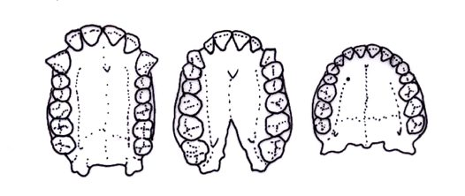(note: they are not sketched to scale) (12 marks)

1. Describe the identifying characteristics of each of the specimens and outline the change in appearance in an evolutionary context. (6 marks)
2. Outline what other morphological characteristics would have changed in parallel to the dental adaptations. (3 marks)
3. Label each specimen with an appropriate living primate example.

(3 marks)